Press Release
Glashütte, November 2017

Moritz Grossmann receives Eve’s Watch Award

TEFNUT Twist Classic wins in the “Best Innovation 2017” category

London: This year’s Eve’s Watch Award winners were celebrated at Morton’s Club on 2 November 2017. For the second time now, Eve’s Watch – the only watch magazine for women only – commended outstanding design, dedication, and pioneering achievements in the world of horology. The broadening feminine appeal of the scene is evidenced by a growing number of female watch buyers and collectors as well as by the many charismatic and talented women in prominent positions within the industry. Alongside the “Public Vote” award, more than 50 respected manufactures were rated in a total of 12 categories, including “Best Design”, “Best High Jewellery”, and “Best Newcomer”.

Moritz Grossmann won the Eve’s Watch Award in the “Best Innovation” category, for which Chanel, Fabergé, Hermès, Richard Mille, and Ressence were also nominated. The jury was impressed by the new strap winder of the TEFNUT Twist Classic. The unique mechanism makes it possible to wind the watch with just a few “twists” of the strap attachment at 6 o’clock. Grossmann’s watchmakers developed this solution, which is especially comfortable for smaller timepieces; it can also be operated with gloves or freshly applied nail polish. Moritz Grossmann CEO Christine Hutter is delighted: “Our philosophy of pure watchmaking artistry since 1854 has conquered the present and is now winning the hearts of women as well.

Excerpt from the jury’s accolade: “The TEFNUT Twist is a proper watch, beautifully executed movement and innovative take on a traditional manually wound watch. Timeless and well designed! ... Genuinely new ideas in the world of watches are rare. However, this year Moritz Grossmann wowed Baselworld, and indeed us, with something really innovative – a watch that is wound by the strap via a cylindrical lug attached to its lower half, which goes into the case and winds the mainspring (though one of our esteemed judging panel has seen watches wound in a similar manner from the 19th century). ... It’s an innovation that has a sense of fun but still serves a practical purpose and captured our panel’s imagination – we just had to award it the trophy.“

The Eve’s Watch Awards 2017 were organised with the support of Urb-it, an on-demand lifestyle shopping app. The jury composed of journalists, designers, influencers, purchasers, watchmakers and collectors, most of them women, recognises and represents the unique feminine facets of horology.

More about the TEFNUT Twist

More about Eve’s Watch Award

Moritz Grossmann Uhren:
Moritz Grossmann, born in Dresden in 1826, was deemed a visionary among Germany’s great horologists. In 1854, his friend Ferdinand Adolph Lange persuaded the young, highly talented watchmaker to establish his own mechanical workshop in Glashütte. Apart from building a respected watchmaking business, Grossmann was committed to political and social causes. He established the German School of Watchmaking in 1878. Moritz Grossmann passed away unexpectedly in 1885, after which his manufacture was liquidated.
The spirit of Moritz Grossmann’s horological traditions sprang back to life in 2008 when trained watchmaker Christine Hutter discovered the venerable Glashütte brand and had it re-registered. She developed concepts and was inspired by the vision of reviving Grossmann’s legacy more than 120 years later with a particularly exquisite wristwatch. And she convinced private watch enthusiasts to support her in making this dream come true. On 11 November 2008, she incorporated Grossmann Uhren GmbH in Glashütte.
At Grossmann, gifted watchmakers are preserving traditions without copying historic timepieces. With innovation, superb craftsmanship, a combination of traditional and contemporary manufacturing methods as well as precious materials, they are celebrateing "Pure watchmaking artistry since 1854" in their watches.

www.grossmann-uhren.com

For further information and high-resolution images, please contact:

GROSSMANN UHREN GmbH
Rainer Kern – Director of Communication
Uferstr. 1
01768 Glashütte
Tel: +49-35053-320020
Fax: +49-35053-320099
rainer.kern@grossmann-uhren.com

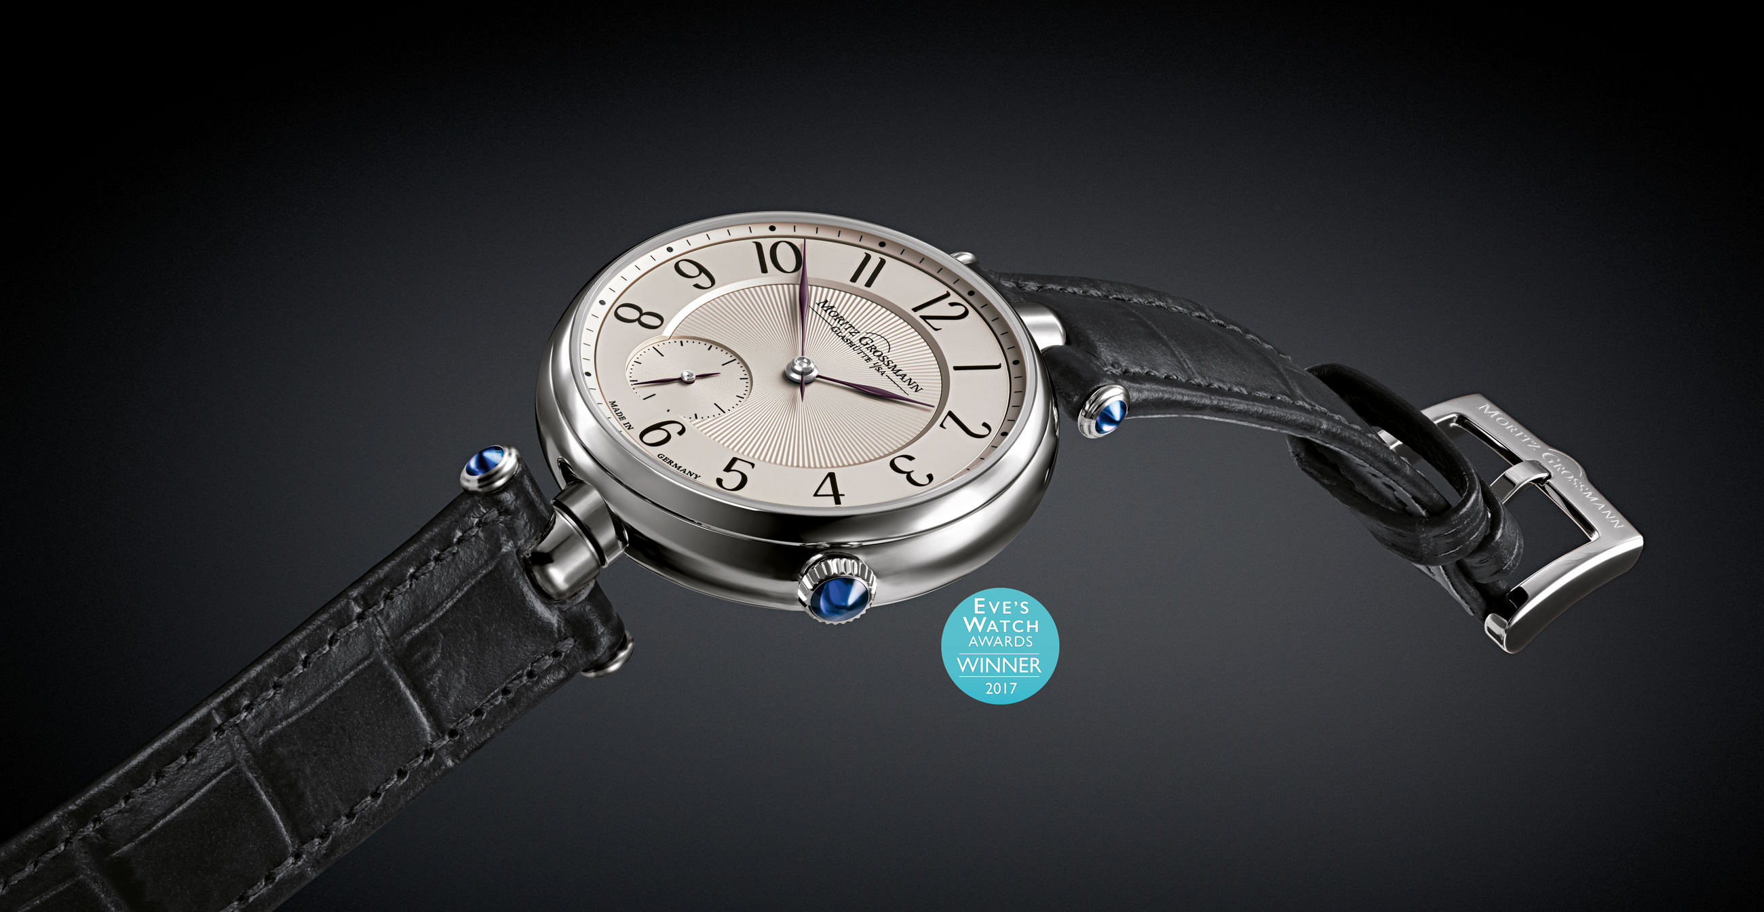

TEFNUT Twist Classic

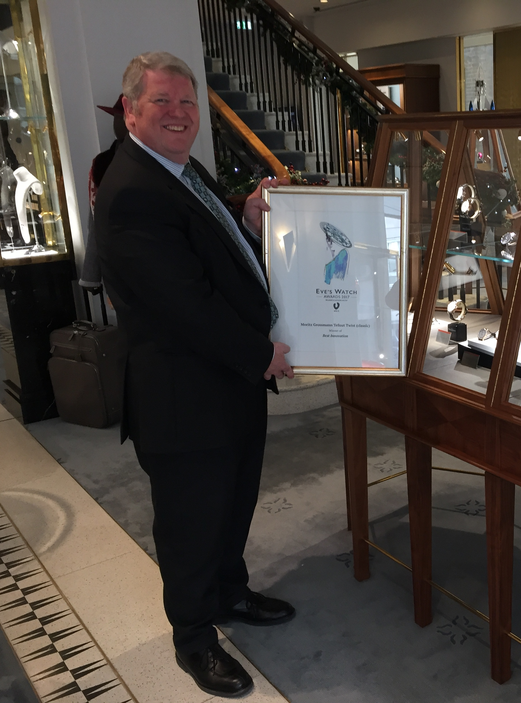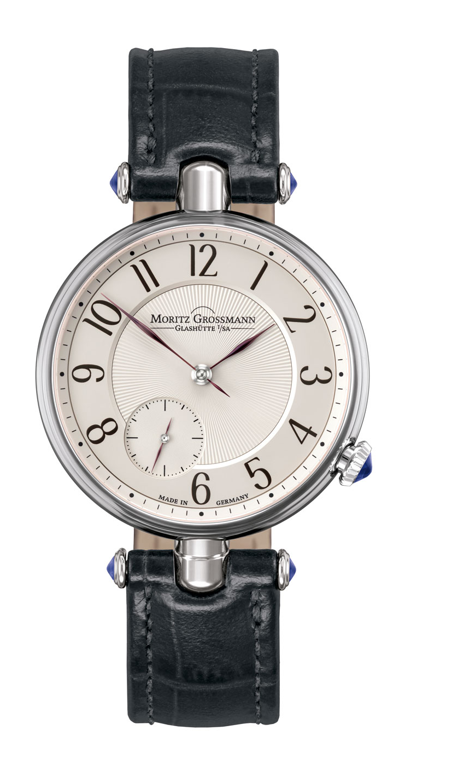

Roy Conners from William & Son, London, TEFNUT Twist Classic
holding the winning certificate

