Press Release
Glashütte, April 2018

Two Moritz Grossmann watches
receive the “Red Dot”

The BENU Tourbillon and the ATUM Enamel rank among the best products in 2018

The “Red Dot” is an international design competition that has been running more than 60 years. This year, the jury assessed over 6,000 pieces in 48 categories from 59 countries against strict design criteria. Only about 25% of the entries won an award. Moritz Grossmann won two!
The first “Red Dot Product Design 2018” award went to the BENU Tourbillon in white gold with a black dial. This is a limitation of only 10 pieces worldwide. The timepiece contains some unique features and complications. For example, there is a prominent flying three-minute tourbillon with a stop second device featuring human hair. The oversized 16mm V-shaped tourbillon carriage appears in a large aperture which cuts the minute dial between 25 and 35. A patented secondary minute scale compensates so that time can be read accurately at all times. Finally a guaiacum wood brake ring controls the elegant sweep of the second hand.
The second award went to the ATUM Enamel in rose gold. Another limited edition - this time of 25 pieces – it boasts an exquisite enamel dial which echoes the craftsmanship of early Glashütte. Crisply drawn scales and Roman numerals contrast against the gleaming white of the Grand Feu enamel. Eye-catchers include the blue “XII” and the beautiful hands which – like all of our hands – have been individually sculpted, by hand, in-house, and then annealed to the rare brown-violet hue which is Moritz Grossmann’s signature.

We are very proud of these two awards. They are a tribute to the skill and creativity of our dedicated designers and master-watchmakers.

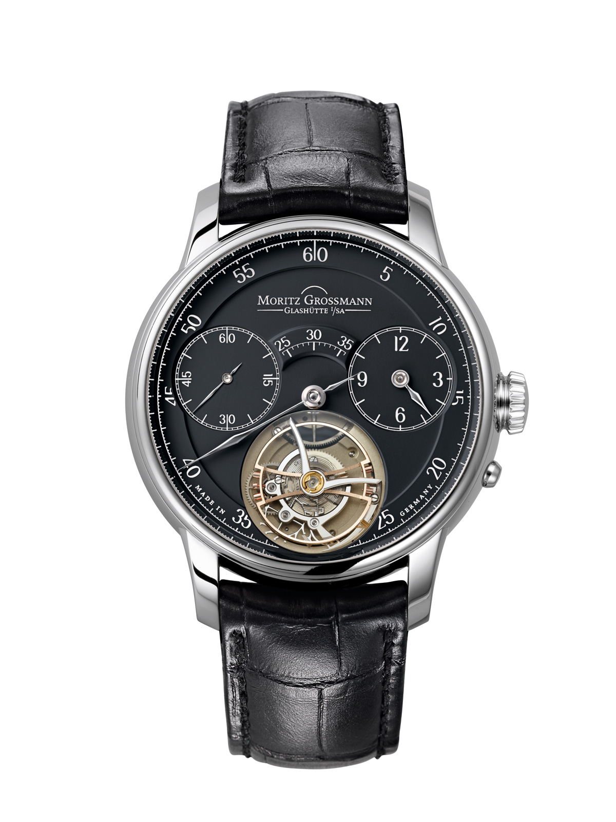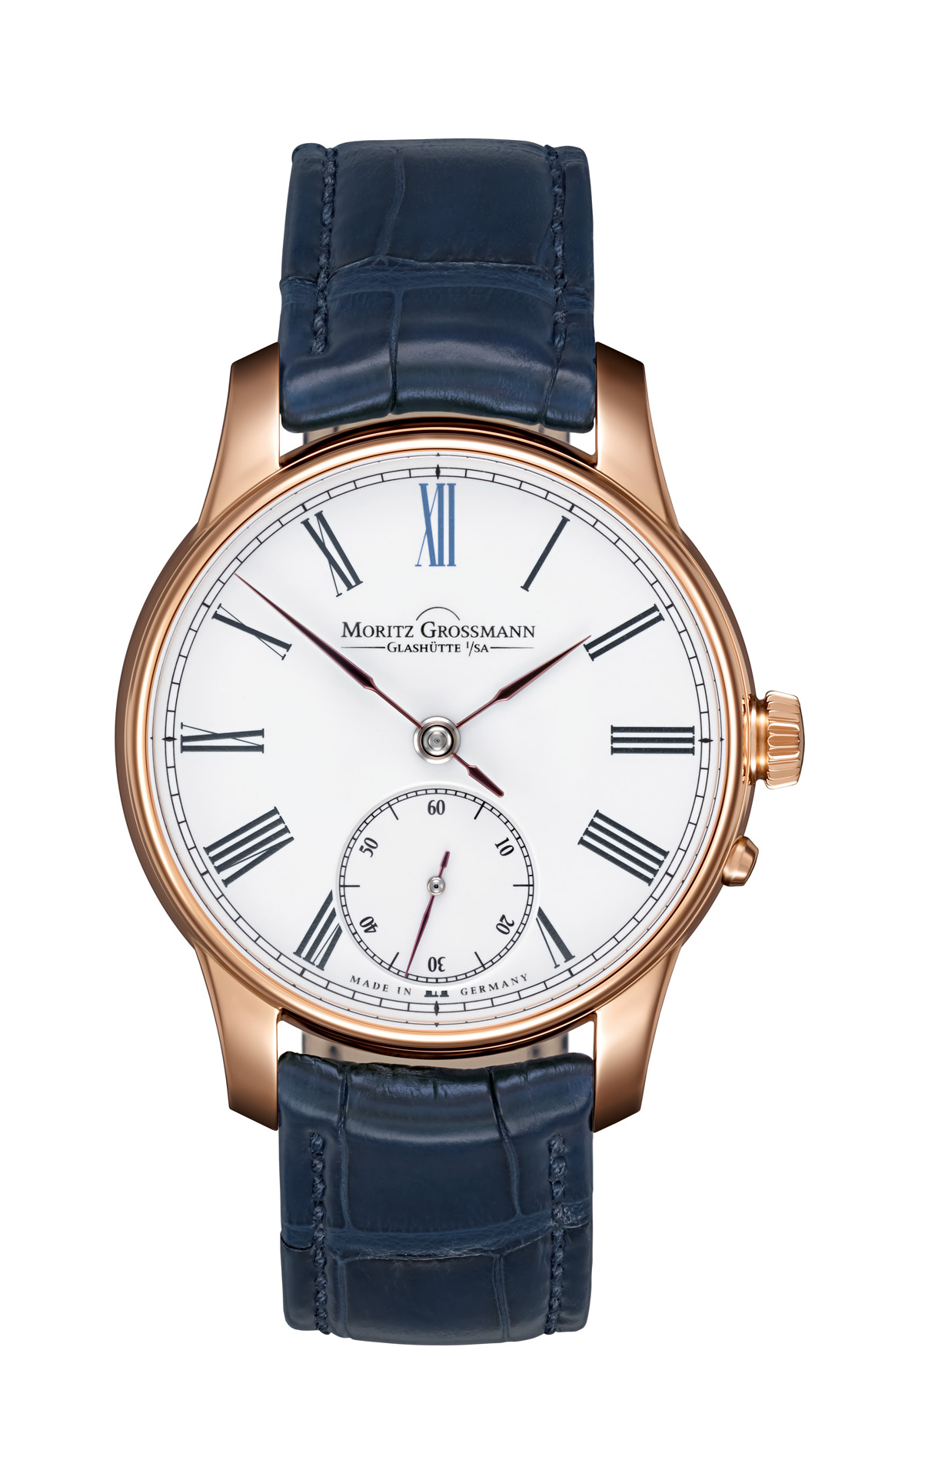
BENU Tourbillon ATUM Enamel

Moritz Grossmann Uhren:
Moritz Grossmann, born in Dresden in 1826, was deemed a visionary among Germany's great horologists. In 1854, his friend Ferdinand Adolph Lange persuaded the young, highly talented watchmaker to establish his own mechanical workshop in Glashütte. Apart from building a respected watchmaking business, Grossmann was committed to political and social causes. He established the German School of Watchmaking in 1878. Moritz Grossmann passed away unexpectedly in 1885, after which his manufacture was liquidated.
The spirit of Moritz Grossmann's horological traditions sprang back to life in 2008 when trained watchmaker Christine Hutter discovered the venerable Glashütte brand and had it re-registered. She developed concepts and was inspired by the vision of reviving Grossmann's legacy more than 120 years later with a particularly exquisite wristwatch. And she convinced private watch enthusiasts to support her in making this dream come true. On 11 November 2008, she incorporated Grossmann Uhren GmbH in Glashütte.
At Grossmann, gifted watchmakers are preserving traditions without copying historic timepieces. With innovation, superb craftsmanship, a combination of traditional and contemporary manufacturing methods as well as precious materials, they celebrate "Pure watchmaking artistry since 1854" with their watches.

www.grossmann-uhren.com

For further information and high-resolution images, please contact:

PRESS CONTACT

GROSSMANN UHREN GmbH
Rainer Kern – Communication Manager
Uferstr. 1
01768 Glashütte, Germany
Tel: 0049-35053-320020
Fax: 0049-35053-320099
E-mail:rainer.kern@grossmann-uhren.com

