PRESS RELEASE - Glashütte 13 December 2024

POWER RESERVE steel - limited edition in mint green and light blue

Moritz Grossmann, together with its retail partner Exquisite Timepieces (USA), presents an exclusive limited edition model: The POWER RESERVE Steel Limited Edition comes with two dial variants in mint green and light blue - the bright colours underline the effect and the great legibility of the innovative, linear power reserve display. The manually crafted steel hands are annealed in blue and match perfectly with the dial colours. The stainless steel case adds an elegant yet sporty character to the timepiece.

Both versions are limited to 10 pieces each and come with a hand-stitched strap made from black buffalo leather. The dial colours are reflected in the coloured stitching in mint green and light blue.

The watches are available exclusively from Exquisite Timepieces in Naples, Florida, USA, https://www.exquisitetimepieces.com/.

The art of watchmaking from Glashütte: the calibre 100.2

The calibre 100.2 is an extension of the calibre 100.1. Thanks to the differential gear, it houses an additional mechanism for displaying the power reserve.

A sapphire crystal back on the reverse of the watch reveals the intricately finished parts in the POWER RESERVE, showcasing the ‘Schönstes deutsches Handwerk’ in the form of the finest cuts and polishes from the Moritz Grossmann manufactory. The calibre 100.2 of the POWER RESERVE also features a cantilevered balance cock with Grossmann micrometre screw and the mass optimised Grossmann balance along with a separately removable winding block.

The Grossmann manual winder with pusher

Grossmann manual winder with pusher contains a perfected hand setting mechanism, which eliminates two potential problem areas: avoiding the ingress of foreign particles during the adjustment process and altering the hands unintentionally when pushing the crown back into place. After a short pull on the winding crown, the mechanism switches to hand setting and simultaneously stops the movement. The crown immediately returns to its original position, allowing the hands to be adjusted precisely. The movement is then restarted using the pusher below the winding crown without having to move the crown again. At the same time, the mechanism is reset to winding mode.

Link to the timepieces:

https://www.exquisitetimepieces.com/moritz-grossmann-heritage-power-reserve-mint-green-dial-limited-edition.html

https://www.exquisitetimepieces.com/moritz-grossmann-heritage-power-reserve-light-blue-dial-limited-edition.html

Technical Data

Movement Manufactory calibre 100.2, manual winding, regulated in five positions
No. of parts 227
Jewels 26 jewels, of which 3 in screwed gold chatons
Escapement Lever escapement
Oscillator Shock-absorbed Grossmann balance with 4 inertia screws and 2 poising screws, Nivarox 1 balance spring with No. 80 Breguet terminal curve, Gustav Gerstenberger geometry
Balance Diameter: 14.2 mm, frequency: 18,000 semi-oscillations per hour
Power reserve 42 hours when fully wound
Functions Hours and minutes, subsidiary seconds with stop second, Grossmann manual winder with pusher, power-reserve indicator
Operating elements Crowns in stainless steel to wind the watch and set the time and the date, pusher in stainless steel to start the watch
Case dimensions Diameter: 41.0 mm, height: 11.65 mm
Movement dimensions Diameter: 36.4 mm, height: 5.4 mm
Case Three-part, stainless steel
Dial mint green/ light blue with Arabic numerals
Hands Manually crafted, steel, annealed to a blue hue
Crystal/display back Sapphire crystal, antireflective coating on one side
Strap Hand-stitched buffalo leather with solid prong buckle in stainless steel
Special features Grossmann balance; hand setting override and start of movement with lateral pusher; bar-shaped power-reserve indicator with two-coloured display segment driven by a differential wheel train; space-saving modified Glashütte stopwork with backlash; adjustment with Grossmann micrometer screw on cantilevered balance cock; pillar movement with 2/3 plate and pillars made of untreated German silver; 2/3 plate, balance cock and escape-wheel cock hand-engraved; broad horizontal Glashütte ribbing; 3-band snailing on the ratchet wheel; raised gold chatons with pan-head screws; separately removable clutch winder; stop seconds for hand setting

Moritz Grossmann watches:
Moritz Grossmann, born in Dresden in 1826, was deemed a visionary among Germany’s great horologists. In 1854, his friend Ferdinand Adolph Lange persuaded the young, highly talented watchmaker to establish his own mechanical workshop in Glashütte. Apart from building a respected watchmaking business, Grossmann was committed to political and social causes. He established the German School of Watchmaking in 1878. Moritz Grossmann passed away unexpectedly in 1885, after which his manufacture was liquidated.
The spirit of Moritz Grossmann’s horological traditions sprang back to life in 2008 when trained watchmaker Christine Hutter discovered the venerable Glashütte brand and had it re-registered. She developed concepts and was inspired by the vision of reviving Grossmann’s legacy more than 120 years later with a particularly exquisite wristwatch. And she convinced private watch enthusiasts to support her in making this dream come true. On 11 November 2008, she founded Grossmann Uhren GmbH in Glashütte.
At Grossmann, gifted watchmakers are preserving traditions without copying historic timepieces. With innovation, superb craftsmanship, a combination of traditional and contemporary manufacturing methods as well as precious materials, they are celebrating ‘Schönstes deutsches Handwerk’ with their timepieces.

Image material to download:

https://my.hidrive.com/share/s88wwzo99t

Further information about Grossmann Uhren GmbH available to download:

https://my.hidrive.com/share/8p0kgeshxo

Grossmann Uhren GmbH/ Exquisite Timepieces:

https://www.grossmann-uhren.com/

https://www.exquisitetimepieces.com/

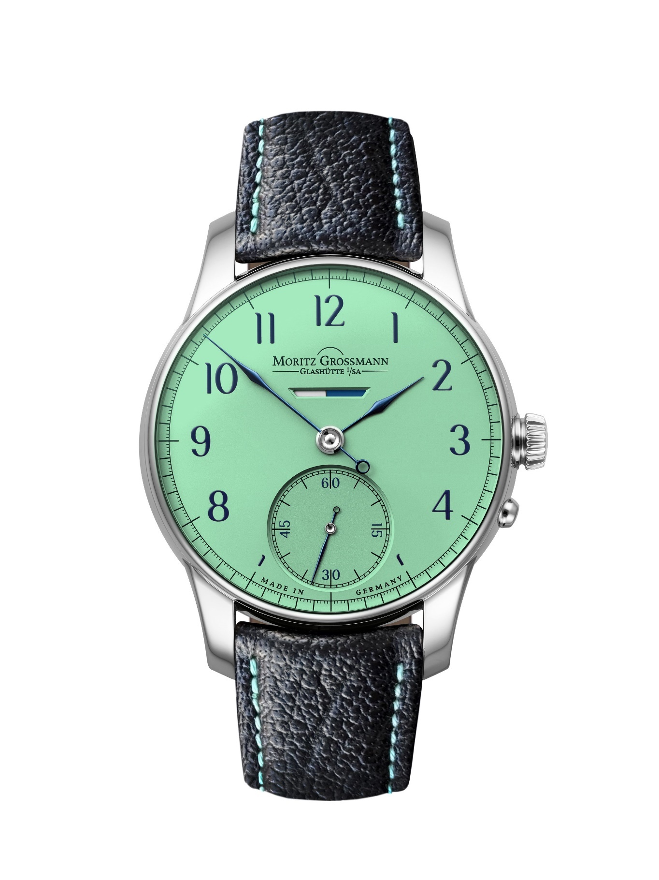
POWER RESERVE Limited Edition in mint green

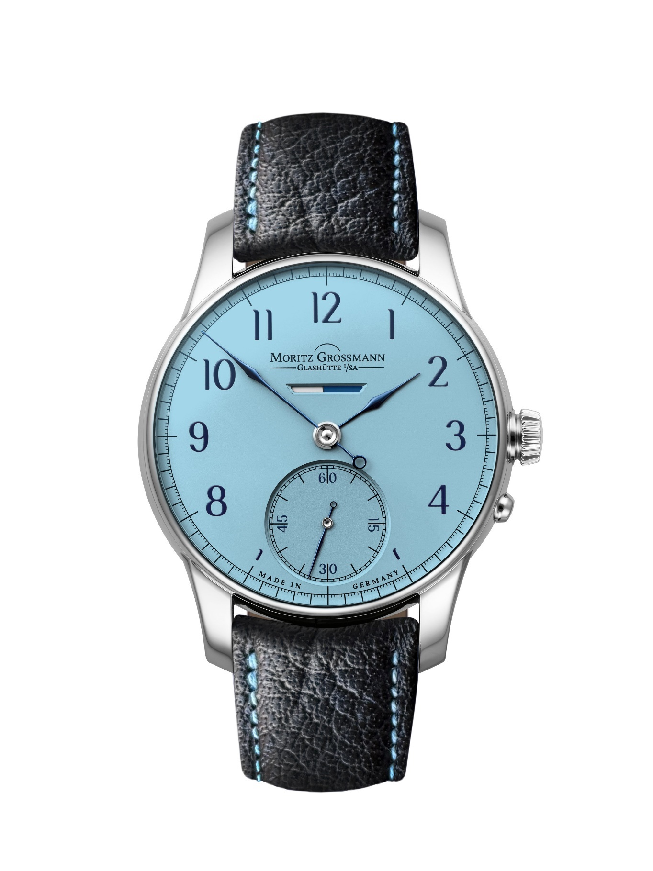
POWER RESERVE Limited Edition in light blue

